**Data in the National Hockey League (NHL)**

Philip Kelly

D00266046

Data Selected – 2023 NHL Predictions (Mejía, 2023).

1. Introduction

Hockey is one of the biggest sports in the USA, Canada and Scandinavia due to their climates. Because of this the most followed ice hockey competition the NHL, National Hockey League has a massive popularity globally. Ice Hockey is played with two teams with five players from each team on the ice at a time. Substitutions happen fast and regular. The goal is to hit the ice hockey puck into the other team’s net past the opposing team’s goalie, called a goaltender. A game in the NHL, consists of three, twenty-minute periods and the clock is stopped whenever there is a break or a foul. The NHL is made up of 32 teams, 25 from the United States and 7 from Canada (NHL, 2023). It is an 82-game season with the best teams advancing to the Stanley Cup playoffs in pursuit of claiming the most prestigious trophy in ice hockey. The first NHL season took place in 1917 with four teams competing, the Montreal Canadiens, Montreal Wanderers, Ottawa Senators and the Toronto Arenas (History, 2021). Two of these teams still compete in NHL today, the Canadiens and the Senators. Throughout the year many teams have joined the NHL to make it what it is today.

A major factor of hockey is goals, assists, save percentage, minutes on ice, points, shot percentage, win percentage and many others. This of course means there is a lot of data collected for the NHL and is forever growing with new technology. I am going to attempt to answer many questions I have, apply data visualizing tools to help me answer them, clean the data, compare statistical data and look for insights and categorize the data.

1. Why I chose this data set.

I chose this data set as I am a big sports fan and have been to an NHL game, support an NHL team and have NHL jerseys at home. My team is the New Jersey Devils, I seen them play in march of this year against Tampa Bay lightning at the prudential center in Newark, New Jersey. Lightning won the game via shoot out. I had a great time there and I have remained up to date with the Devils games and even watch a few if they are on early. The Devils have gone from being near the bottom of the standing the last 6 years to being 2nd favorites to win the Stanley Cup this year. This is not uncommon to happen to a team and keeps the NHL interesting by having different teams challenging every year. The NHL is not very popular in Ireland, in fact there is only 1 professional Ice hockey team on the island of Ireland, the Belfast Giants Who compete in the UK elite hockey league and in fact are the defending champions and are competing in the European hockey champions league this year.

Some of the questions I have are:

1) Is "home advantage" a thing in the NHL?

2) Does having a high payroll guarantee success?

3) Which team has the highest Stanley Cup win percentage?

4) Does 1 conference have the edge on the other?

5) Can I make a statistically backed prediction for the 2023/24 NHL Season?

**My goal**

My goal of this report and CA is to capitalize of learning how much data plays in sports, more specifically the National Hockey League. To achieve this, I have come up with questions and have used a data source from data.fivethirtyeight titled NHL 2022/23 Predictions and have looked through the data to help come up with answers to my questions (Mejía, 2023). Having attended my first and only NHL Game in March 2023 at the Prudential Centre between the New Jersey Devils and the Tampa Bay Lightning, I have remained a Devils fan since and follow their games regularly. I feel this CA will help my understanding of the game and how it has evolved from 1918 to 2023 and in between.

1. **Does home advantage make a difference in the NHL?**

In the 22/23 season, 59% of wins came from the home team. This is low compared to other sports such as soccer or basketball. A factor is that all NHL surfaces are the exact same size and there is little difference between the stadiums. Typically, the home support accounts for over 80% of attendance but shows no difference to the players with some teams who actually had better away form than home form. In the 2023 Stanley Cup semi final series between the Golden Knights and Dallas Stars. Vegas won 6-0 in Dallas to put One foot into the final. This result concluded to me that the strength of the team makes a far bigger difference than home advantage does. In this years Stanley Cup playoffs, In the 91 games played, the away team in fact won 49 times with 42 wins for the home team, showing home advantage will not help much in NHL (NHL, 2023).

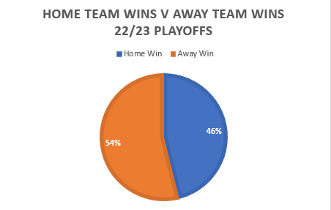

1. **Does a higher wage bill deliver higher success?**

I now have researched the 32 teams wage payroll for last season to compare to the on-ice finishing position. Colorado Avalanche lead the way with a payroll of $121,335,000 (spotrac, 2023). Chicago Blackhawks ends off the list with a payroll nearly 40 million less than the Avalanche at $87,162,816 (spotrac, 2023). In terms of these teams’ results, I checked team ratings from the excel and sure enough the Avalanche place inside the top 3 and Chicago in last position unsurprisingly. Champions, Vegas Golden Knights rank 3rd showing that their getting value for money (spotrac, 2023). The biggest overachievers financially wise hands down are the Carolina Hurricanes who place under the 100 million mark at $96,005,000 (spotrac, 2023), they made it convincingly into the final 4 and look to repeat that this season (spotrac, 2023). As for underachievers St. Louis Blues rank 2nd with a payroll of $119,250,000! (spotrac, 2023), for a team who didn’t even make the playoffs last year and are near the bottom again, I’m sure Blues fans will wonder if they will ever see a title challenge for all their investment? This led me to wonder how many of the top 16 spenders actually make the final 16? Luckily, I will tell you! The 22/23 playoffs were made out of 9 of the 16 teams with the highest payroll, just over half. Since 2021, 13 of the 16 have qualified for the playoffs. This shows that while having a payroll in the top three has brought the cup the last three years, it doesn’t guarantee success. Proper investment into future prospects and successful coaching has shown to be a major key element to a team’s performance but with a good scout department, the financial burden will be less as teams like Carolina and New Jersey have shown (spotrac, 2023).

**3) Stanley Cup Wins & Win Percentage.**

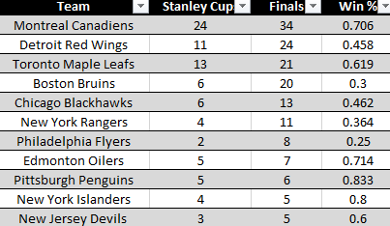

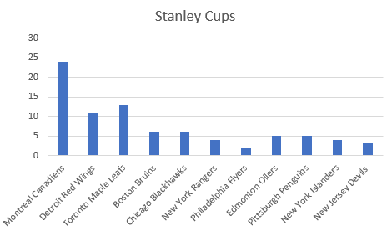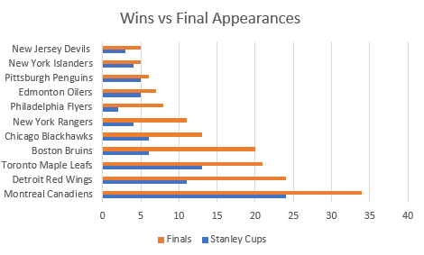

Figure 5 - Most Stanley Cup wins. Figure 6 - Stanley Cup wins vs final appearances.

Here I have the data for the Stanley Cup winners since its creation. I have made a table shown in above. It shows the Montreal Canadians have the most Stanley Cups in history, however this shouldn’t be a surprise since they have been competing in every NHL season so far (NHL, 2023). I decided to then make a win percentage column and a graph showing wins and final appearances. The results show the Pittsburgh Penguins have the best percentage with 0.833 having won 5 Stanley Cups out of 6 finals (NHL, 2023). The worst record for an NHL team in finals belongs to the Philadelphia Flyers with 2 wins in 8 final appearances, a brutal 0.25-win rate (NHL, 2023). The current champions the Vegas Golden Knights have 2 final appearances and 1 win however I only included teams that appeared in at least 5 finals as a 6 wins out of 12 is more impressive than a 1 win in 2 finals (NHL, 2023). The only team to have a 100%-win percentage in the final is the Colorado Avalanche with three wins out of three, the most recent being in 2022 (NHL, 2023).

The Canadiens started in 1917, as I said earlier so I checked for the most recent team in the chart and it is my beloved New Jersey Devils with 3 Stanley Cups and 5 final appearances since their founding in 1982, 41 years ago (NHL, 2023).

**4) Does 1 area / conference have the advantage over the other?**

There are two conferences in the NHL, the eastern and western, the winner of each through the season face each other in the Stanley Cup final, so it is always eastern vs western (NHL, 2023). Looking through the winners each season, something came to mind, they were all mainly eastern teams, so I noted every winner since the first NHL Stanley Cup and found that in the 97 finals played, a whopping 77 have been won by eastern conference teams (NHL, 2023). As shown in figure 4, eastern teams have won 77 times (79%) compared to only 20 for western teams (21%). Only the Blackhawks and the Oilers have more than 1 Cup to contribute to the western conference (NHL, 2023). In the last 10 years however, the split has got better as it was 6 to 4 in favor of eastern teams but still non the less still the east has had more success in the final. This also made me think of a reason why the New Jersey moved conferences from west to east when they changed location from Kansas City in 1982 (The Pink Puck, 2019), based on the data of wins, this looks like a very successful decision as the Devils now have 3 Stanley Cups since moving to the Prudential Centre in Newark, NJ from Kansas City (The Pink Puck, 2019). Since there are 16 teams in each division the last 30 years, the data favors eastern teams still with only the Golden Knights major investment in their team evening out the conferences recently (NHL, 2023).

figure 4 - Stanley Cups based on conferences

As shown in figure 4, eastern teams have won 79% of all NHL Stanley Cup finals. The eastern conference is made out most of the Canadian teams and teams from the east of America such as New York, Philadelphia and Florida (NHL, 2023), Canada has a much lower climate and Canadian players make up most of the NHL so on further inspection I feel this could be why the gap is so big (CANADIM, 2023). The two most successful teams, the Canadians and the Maple Leaf’s, the two largest Canadian teams account for 37 of the eastern wins (NHL, 2023).

**5) Using the data to make a prediction for the 2023/2024 Season.**

Now I am going to use the data to make a prediction for the 2023/2024 NHL season.

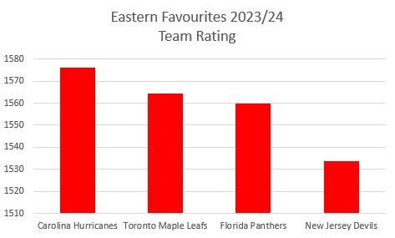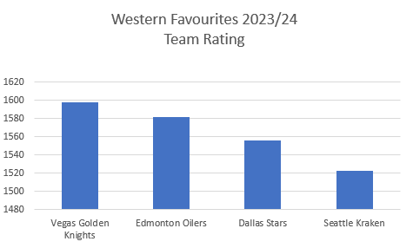

Figure 1 – Eastern Team Ratings May 2023 Figure 2 – Western Team Ratings May 2023

As you can see from the graphs I created above. I believe the Carolina Hurricanes and Las Vegas Golden Knight will win their conferences this season. The defending champions the Golden Knights finished with a team rating of 1597.674 the highest in the NHL and have kept most of their championship winning team there too, so I believe they will win the pacific division quite comfortably with Seattle Kraken finishing 2nd. I am predicting a battle between the Oilers and the Stars as shown in figure 2 for top spot in the central division, the oilers have a higher rating by 25.475 however their star player Connor McDavid is only returning from injury so it might be a rocky start for the Oilers and so Dallas can try to capitalize with the Avalanche finishing a comfortable 3rd.

For the Eastern conference I have selected the Carolina Hurricanes to go one better from last season. I also select them to win the Metropolitan division too but I don’t think it will be that easy as they have lost players due to retirement and their strongest challengers, the New Jersey Devils have made huge signings such as locking down Timo Meier. I predict both the Carolina Hurricanes and the New Jersey Devils to finish 1st and 2nd in the Metropolitan division and meet in the quarter finals of the Stanley Cup Playoffs which can go either way. I am predicting a three-way battle for the Atlantic division between the Boston Bruins, Toronto Maple Leaf’s and last year’s beaten finalists, Florida Panthers. I suspect the advantage lies Boston’s way as they were knocked out very early last year shockingly as they were arguably the most dominant team last season, I suspect they will learn from their mistakes and claim 1st and make it into the quarter finals at least with Toronto and Florida finishing the top 3 respectively.

Figure 3 shows my Stanley Cup predicted bracket and winners. I have chosen the Colorado Avalanche to reclaim the Stanley Cup which they last won in 2022 by beating the New Jersey Devils in the final. We see last season how much the teams experience plays into the playoffs as many of the past recent winners have all got far and that’s why I have picked the Avalanche and the Devils to contest the final. as I said earlier, I think the Avalanche will finish 3rd comfortably in their division and save energy for the playoffs as they can beat any team on their day. The young devil’s team will fall just short in my opinion as they will be off the back of a 100-game season with many of the players 25 or younger, giving them an experience disadvantage, which effectively knocked them out last year too. The data also shows the last time the Devils played in the final was 2012 which they lost to the Kings. As for Vegas I think they will make the semifinal however its practically impossible to win nearly all of 200 games in 2 years, that’s why I think they won’t retain the cup.

The data I collected from the excel helped me make these predictions as I used the team rating, head-to-head, goals scored and how far they have got in recent years and so came up with my picks.

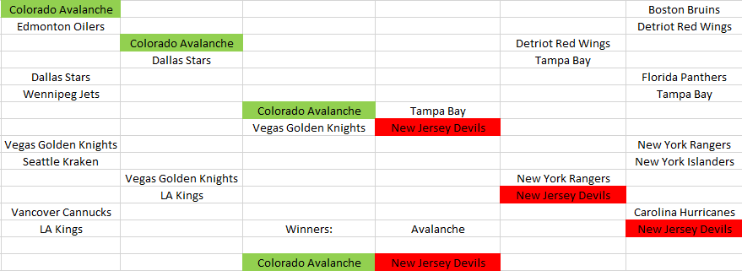

Figure 3 – My prediction bracket for Stanley Cup Playoffs 23/24

To answer my question: Can I make a statistically backed prediction for the 2023/24 NHL Season?

Yes, I can, I am satisfied this will be a good prediction and is based on recent statistics and data.

I used team rating and previous history to make a good prediction.

**What I have learned**

Firstly, I really enjoyed this project as not only was it interesting to do research and get my questions answered but I also learned so much about the history of the NHL and its teams. At first it was daunting seeing the amount of data however I found how to manage and clean it to answer my questions from earlier.

I have learned how to draw results from a large data source as this had over 60000 rows of game data. From quantitative data such as team rating and score, to qualitative data such as team name and abbreviations. To navigate key elements of the data I specifically looked for the last time a certain year appeared, indicating it was the Stanley Cup final game of that season. I learned new ways of extracting from the metadata such as the previous point and also when I used the team rating to help me predict the Stanley Cup and division result for next season. I looked at the final game played in 2023 for each team and checked their team rating to aid my predicting. Based on how the season is going (12 games in currently at time of writing), the Rangers, Golden Knights, Bruins and Avalanche are leading their divisions, all 4 teams I predicted would make the playoffs and my predicted winners the Avalanche currently leading their division too.

From my questions I learned I there is a difference between eastern and western conference success in finals. I can make a good prediction for the next NHL season. The win percentage of teams in the Stanley Cup final.

I also learned the number of metadata involved in the NHL.

I was able to clean the data and draw my own conclusions such as the win rate per conference and home advantage.

I picked out the right rows and columns from the data to help me answer my questions such as the last row of a year being the final.

Finally, as I said earlier, I really enjoyed this project and I believe it has improved my skills to becoming a future data scientist.

# References

CANADIM. (2023, November 29). *Climate and Nature*. Retrieved from CANADIM: https://www.canadim.com/blog/living-in-canada-vs-usa/#:~:text=Canada%2C%20known%20for%20its%20diverse,and%20Toronto%20enjoy%20milder%20climates.

History. (2021, September 10). *National Hockey League opens its first season*. Retrieved from history.com: https://www.history.com/this-day-in-history/national-hockey-league-nhl-opens-its-first-season

How they Play. (2023, 08 9). *Basic Rules of NHL Hockey: A Visual Guide*. Retrieved from How They Play: https://howtheyplay.com/team-sports/Basic-Rules-NHL-Hockey-Visual-Guide

Mejía, R. B. (2023, June 13). *2022-23 NHL Predictions.* Retrieved from FiveThirtyEight: https://projects.fivethirtyeight.com/2023-nhl-predictions/

NHL. (2023, December 4). *nhl.com*. Retrieved from Standings: https://www.nhl.com/standings/2023-12-03/division

NHL. (2023, June 04). *Stanley Cup Champions*. Retrieved from nhl.com: https://www.nhl.com/news/nhl-stanley-cup-champions-winners-complete-list-287705398

spotrac. (2023, 12 04). *NHL Team Cash Payroll Tracker*. Retrieved from spotrac.com: https://www.spotrac.com/nhl/cash/

The Pink Puck. (2019, June 30). *This day in hockey history - Speak of the devils*. Retrieved from thepinkpuck.com: https://thepinkpuck.com/2019/06/30/this-day-in-hockey-history-june-30-1982-speak-of-the-devils/